Manage nodes:

Dashboard……..>Go to the Manage Jenkins………>Manage Nodes….>Click on New Node……..>Give a name for the node, choose the Dumb slave option and click on Ok………>

Before launch we need to install power shell plugin.

 Enter the details of the node slave machine. In the below example, we are considering the slave machine to be a windows machine, hence the option of “Let Jenkins control this Windows slave as a Windows service” was chosen as the launch method. We also need to add the necessary details of the slave node such as the node name and the login credentials for the node machine. Click the Save button. The Labels for which the name is entered as “New_Slave” is what can be used to configure jobs to use this slave machine.

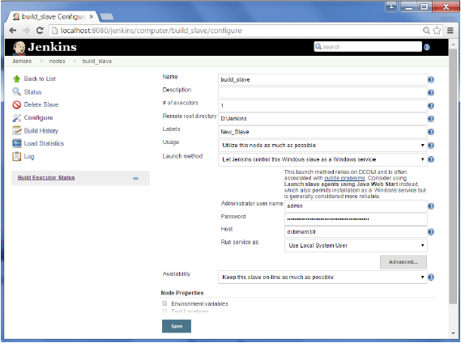

Once the above steps are completed, the new node machine will initially be in an offline state, but will come online if all the settings in the previous screen were entered correctly. One can at any time make the node slave machine as offline if required.

Ofter creating job for node we need follow below steps:

1. Creating job as a free-style and cleck save
2. In second console check mark….>

|  |
| --- |
|  |
| Restrict where this project can be run | | | [Help for feature: Restrict where this project can be run](http://localhost:8080/job/d/configure) |
|  |  | |  |
|  |  |  |  |
|  | Label Expression…>type here slave name  3.cleck save chec the build status |  |  |